**Chapter 8 - Diseases**

**All Lectures Uploaded on YouTube:**

[**https://tinyurl.com/fkm10-biology**](https://tinyurl.com/fkm10-biology)

## 

**8.1. Diseases**

* A **disease** is a condition that affects the normal functioning of an organism, causing harm or discomfort.
* Causes: genetics, environment, lifestyle, or infection.
* **Disease vs Illness**:
  + Disease → objective, biological, medical condition.
  + Illness → subjective experience of feeling unwell (social, cultural, psychological factors included).

### **Types of Diseases (by Duration)**

1. **Acute Diseases** → Short-term, resolve quickly (e.g., pneumonia).
2. **Chronic Diseases** → Long-term, persist/worsen over time (e.g., diabetes).

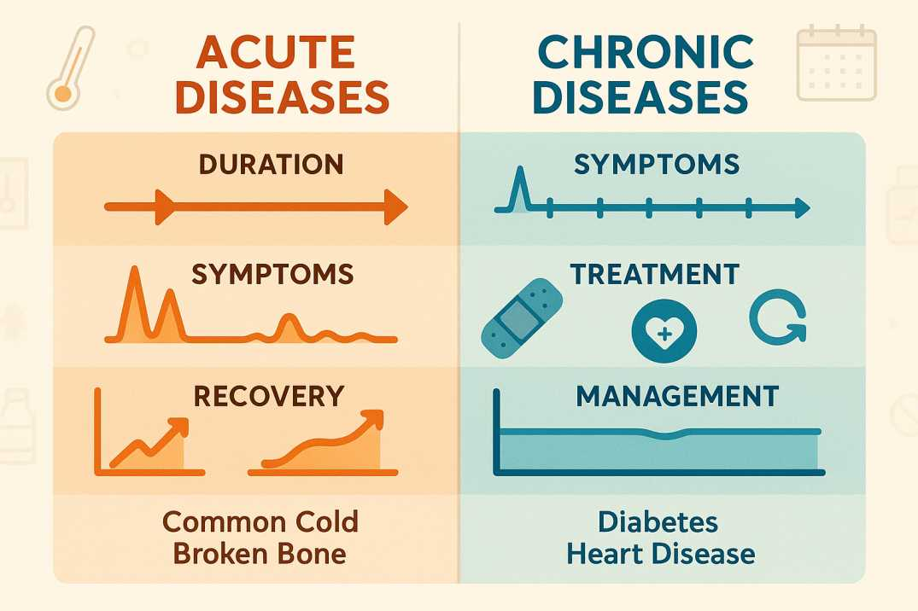

### **Types of Diseases (by Cause)**

* **Infectious diseases** (spread by pathogens).
* **Non-infectious diseases** (not caused by pathogens).

## **8.2. Infectious Diseases**

* Spread from person-to-person or animals-to-humans.
* **Pathogen**: an agent that causes disease (bacteria, viruses, fungi, protozoa, parasitic worms).
* Spread through:
  + Skin contact
  + Bodily fluids
  + Contaminated food/water
  + Airborne droplets
  + Contaminated objects

**8.2.1. Types of Infectious Diseases**

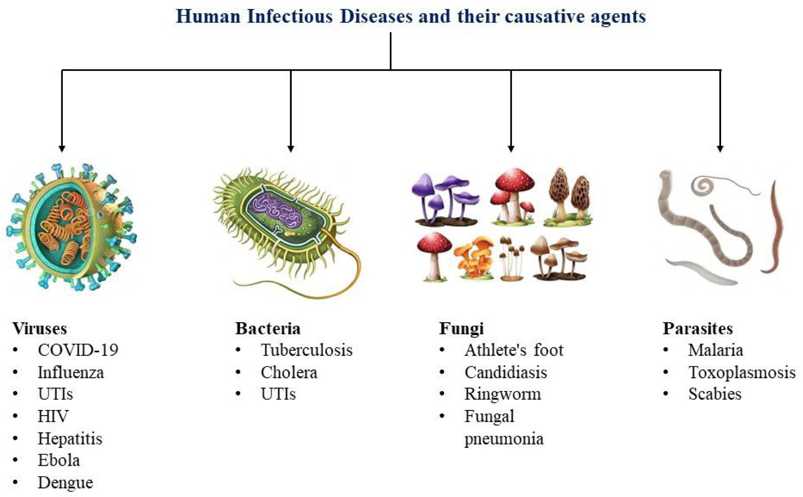

## **8.3. Zoonotic Diseases**

* **Zoonosis**: Infectious disease transmitted from animals to humans.
* Can be caused by: viruses, bacteria, fungi, protozoa, parasites.
* **Symptoms** vary depending on disease (e.g., bird flu → fever, cough, fatigue, sore throat, runny nose, headache).

### **8.3.1. Types of Zoonotic Diseases**

1. **Viral zoonoses** → Rabies (mammals), Bird flu (birds).
2. **Bacterial zoonoses** → Anthrax (cattle), Plague (rat fleas).
3. **Fungal zoonoses** → Ringworm (cats, cattle).
4. **Protozoan zoonoses** → African sleeping sickness (tsetse fly), Beaver fever (beavers).
5. **Parasitic worm zoonoses** → Snail fever (snails), Tapeworm (pigs).

### **8.3.2. Transmission of Zoonotic Diseases**

* Bites, scratches, ingestion, contact with contaminated waste/products.
* Over 60% of human pathogens are zoonotic in origin.

## **8.4. Vector-Borne Diseases**

* **Vector**: the living organism that transmits pathogens from infected → healthy hosts.
* Examples of vectors: mosquitoes, ticks, fleas, lice, mites, flies.

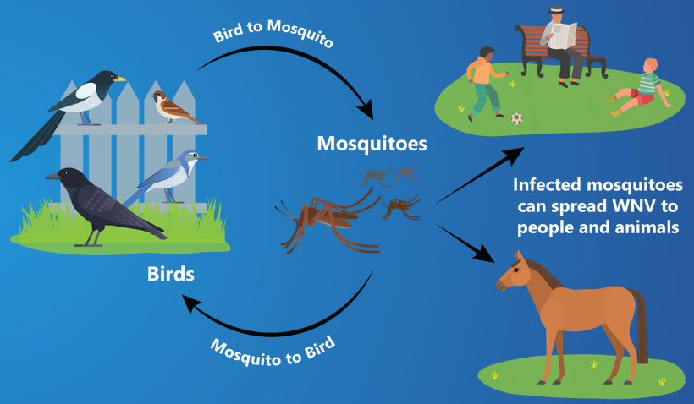

### **Types of Vectors**

1. **Biting Vectors** → Mosquito, mite, flea, tick (pathogens multiply inside the body, transmitted by biting).
2. **Carrier Vectors** → Houseflies (pick pathogens on body, spread by contact).

### **Examples of Vector-Borne Diseases**

* Malaria (mosquito), Dengue fever (mosquito), Lyme disease (tick).

## **8.5. Non-Infectious Diseases**

* Not caused by pathogens, cannot spread.

### **Types**

1. **Physiological diseases** (e.g., Diabetes Type 2, cancer).
2. **Genetic disorders** (e.g., sickle cell anaemia, colour blindness).
3. **Autoimmune diseases** (e.g., type 1 diabetes, rheumatoid arthritis).
4. **Nutritional deficiency diseases** (e.g., scurvy, rickets).
5. **Environmental diseases** (e.g., lung cancer from smoking, skin cancer from UV rays).
6. **Degenerative diseases** (e.g., osteopososis, osteoarthritis, Alzheimer’s disease).
7. **Psychological disorders** (e.g., anxiety, depression).

## **8.6. COVID-19**

* Caused by **Coronavirus SARS-CoV-2**.
* Global pandemic (2020–2022).
* An **acute disease** affecting multiple body systems:

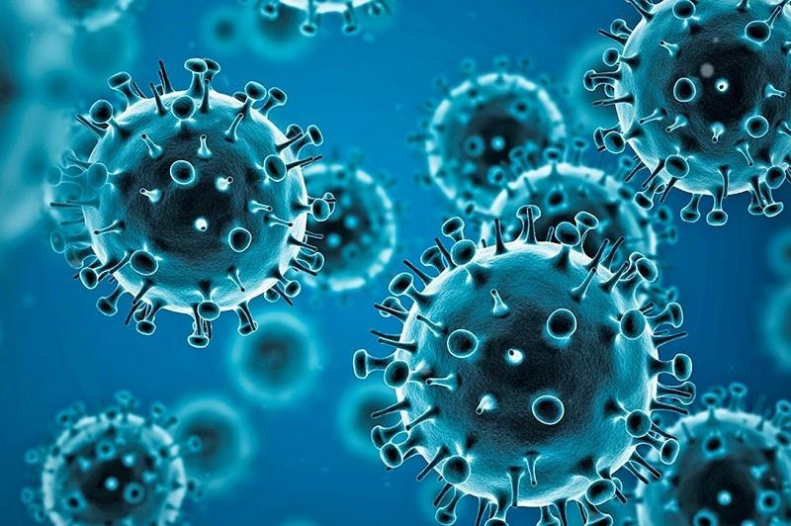

### **Effects**

1. **Respiratory** → Breathing difficulty, pneumonia.
2. **Cardiovascular** → Risk of heart attack, stroke.
3. **Nervous system** → Headache, fatigue, loss of taste/smell.
4. **Digestive system** → Diarrhoea, nausea, vomiting, liver damage.
5. **Urinary system** → Abnormal kidney function.
6. **Immune system** → Weakens immune response.
7. **Mental health** → Anxiety, depression, stress.
8. **Long-term effects** → Permanent lung damage, chronic health issues.

### **Prevention**

* Washing hands frequently
* Wearing masks
* Social distancing
* Staying home if symptomatic
* Vaccination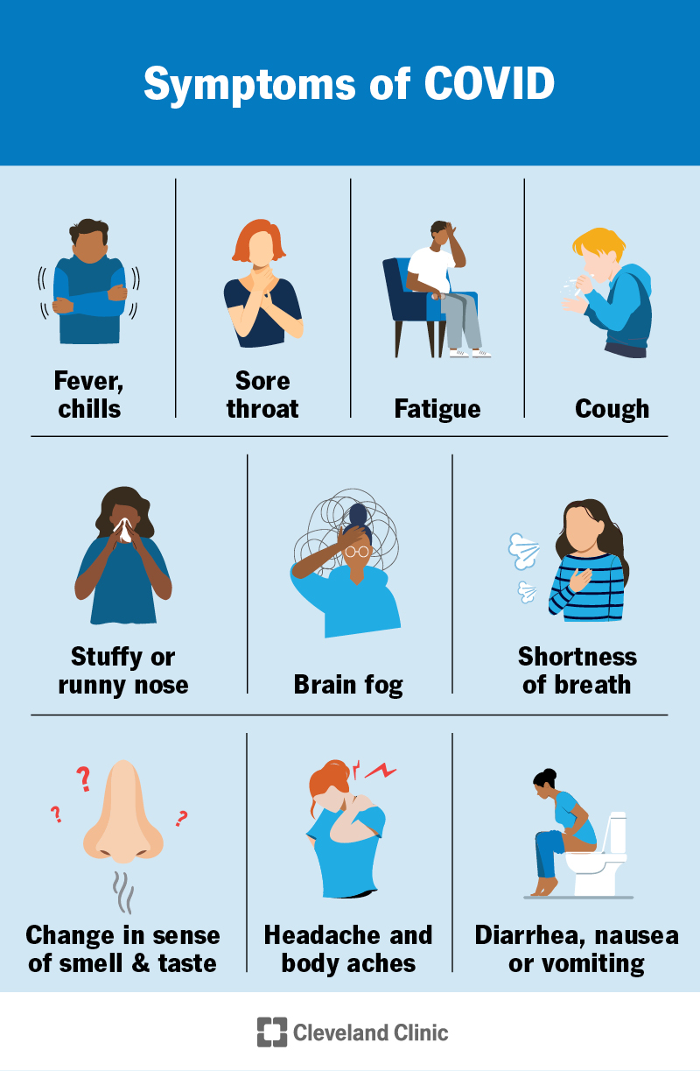

### **Effects on Body Systems**

1. **Urinary System**
   * Abnormal kidney function
   * Kidney damage
2. **Respiratory System**
   * Breathing difficulty
   * Pneumonia
3. **Cardiovascular System**
   * Risk of heart attack
   * Risk of stroke
4. **Nervous System**
   * Headaches
   * Fatigue
   * Loss of taste and smell
   * Anxiety, depression, stress
5. **Digestive System**
   * Diarrhea
   * Nausea, vomiting
   * Liver damage
6. **Immune System**
   * Weakened immune system

## **8.7. AIDS (Acquired Immunodeficiency Syndrome)**

* Caused by **HIV (Human Immunodeficiency Virus)**.
* Attacks the **immune system**, specifically **helper T cells (CD4 T cells)**.
* Weakens the body’s ability to fight infections.

### **Transmission**

* Through infected blood and body fluids
* Sharing contaminated needles, blood transfusions, or instruments

### **Symptoms of AIDS**

* Fever, headache, muscle aches
* Joint pain, swollen lymph nodes
* Diarrhoea, weight loss
* Severe immune dysfunction

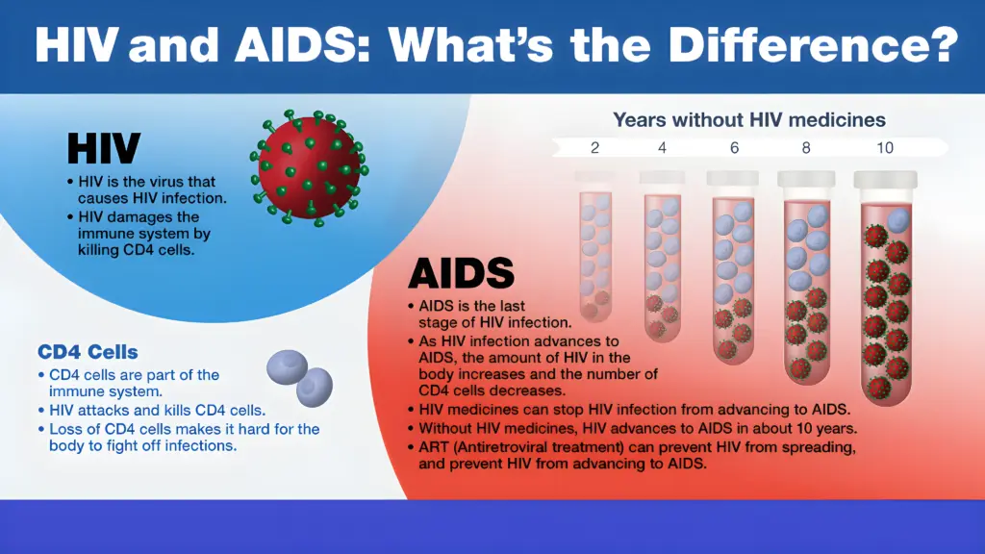

### **Stages of HIV to AIDS**

1. **Stage 1: Asymptomatic**
   * No symptoms
   * Virus multiplies in blood
   * Lasts a few weeks
2. **Stage 2: Mild Symptoms**
   * Mild infections, swollen lymph nodes
   * Can last up to 10 years
3. **Stage 3: Advanced Symptoms**
   * Immune system weakens
   * Opportunistic infections start
4. **Stage 4: AIDS**
   * Severe symptom
   * Rapid decline of CD4+ T cells
   * Many opportunistic infections

### **Treatment**

* **Antiretroviral Therapy (ART)**: manages HIV and prevents AIDS progression
* Early detection and treatment are crucial

**8.8. Diabetes**

* A group of **metabolic disorders** characterised by **high blood sugar levels**.
* Chronic disease.

### **Types of Diabetes**

1. **Type 1 Diabetes (T1D):**
   * An autoimmune disease that destroys insulin-producing cells in the pancreas.
   * Treated from insulin injections.
2. **Type 2 Diabetes (T2D):**
   * Caused by insulin resistance and impaired insulin secretion.
   * Chronic disease.
3. **Gestational Diabetes (GDM):**
   * Develops during pregnancy.
   * Usually reverses after delivery.

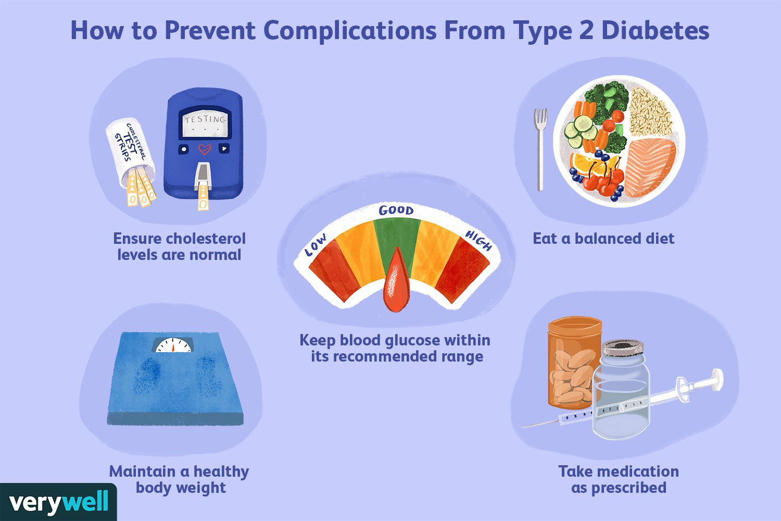

### **Management**

* Medication, diet, and lifestyle changes.

### **Prevention / Management Steps**

* Be more active
* Eat fiber-rich foods
* Eat whole grains
* Lose weight
* Make healthier choices
* Don’t smoke

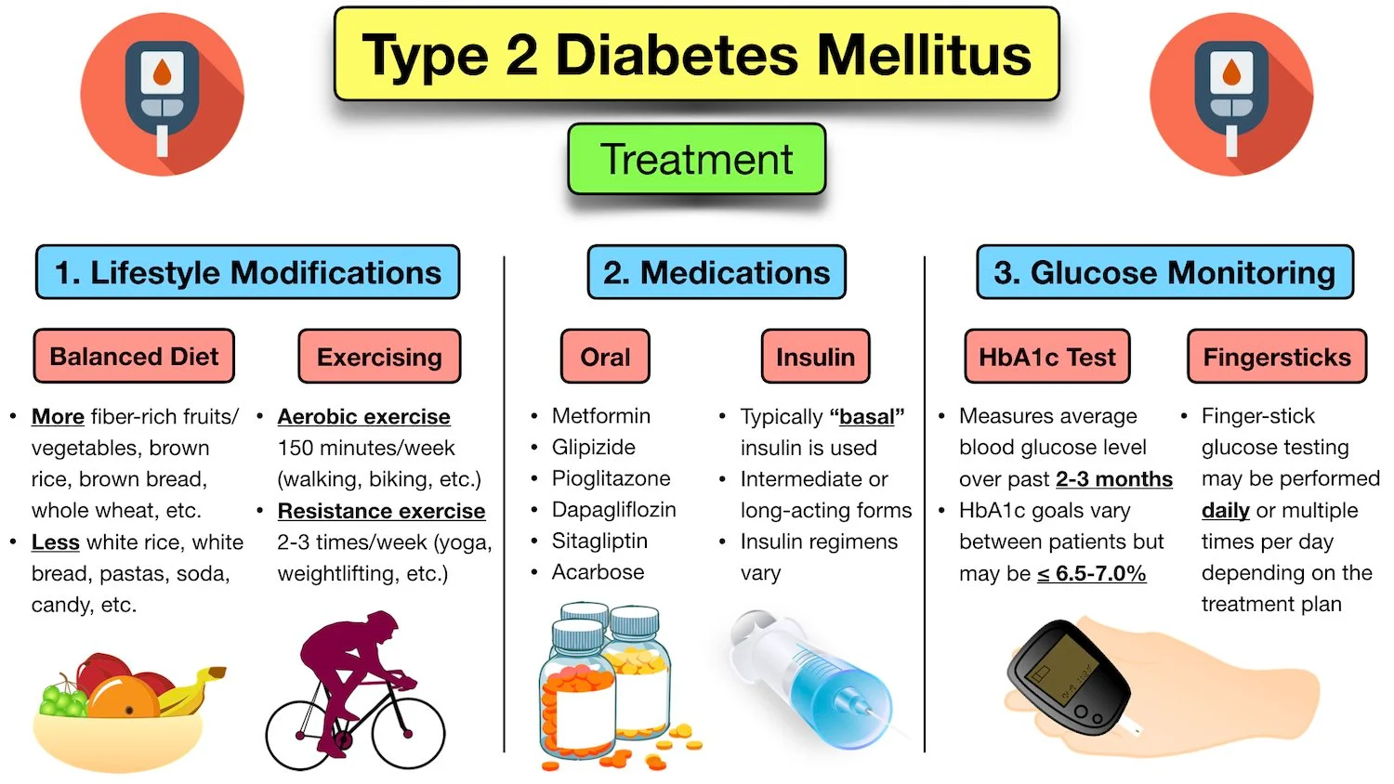

### **Effects of Unmanaged Diabetes**

1. **Short-term Effects**
   * Increased thirst and urination
   * Fatigue, blurred vision
   * Slow-healing wounds
2. **Long-term Effects**
   * Heart diseases, high blood pressure
   * Irregular heartbeat
   * Kidney and nerve damage
   * Retina damage, foot ulcers
   * High cholesterol, high uric acid, high lipid levels
   * High risk of COVID-19
   * Ketoacidosis, memory loss

## **8.9. Plant Diseases in Pakistan**

* Pakistan is mainly an agricultural country where crops are the backbone of its economy.
* Just like humans, plants can also get sick due to microorganisms. In Pakistan, many **fungal diseases** damage important crops.

### **Major Fungal Plant Diseases**

1. **Rust of Wheat**
   * Caused by fungus *Puccinia rustica*.
   * Infects wheat, barley, and rye.
   * Spreads from one plant to another through **air-borne spores**.
   * Can reduce yield by up to **20%**.
   * Appears as reddish-brown spots on leaves and stems.
2. **Smut Disease**
   * Another fungal disease affecting wheat and grasses.
   * Appears as **sooty black powder** replacing grains.
   * Reduces crop yield and quality
   * Caused mainly by fungus *Ustilago*.
3. **Red Rot of Sugarcane**
   * Very destructive disease of sugarcane.
   * Caused by fungus *Colletotrichum falcatum*.
   * Symptoms:
     + Red-colored patches inside sugarcane stem.
     + Dull, reduced juice content.
   * Severely affects sugar production.

### **Control of Plant Diseases**

* Use of **disease-resistant varieties**.
* Proper **crop rotation** (changing crops in fields).
* Use of **fungicides**.
* Early detection and regular monitoring

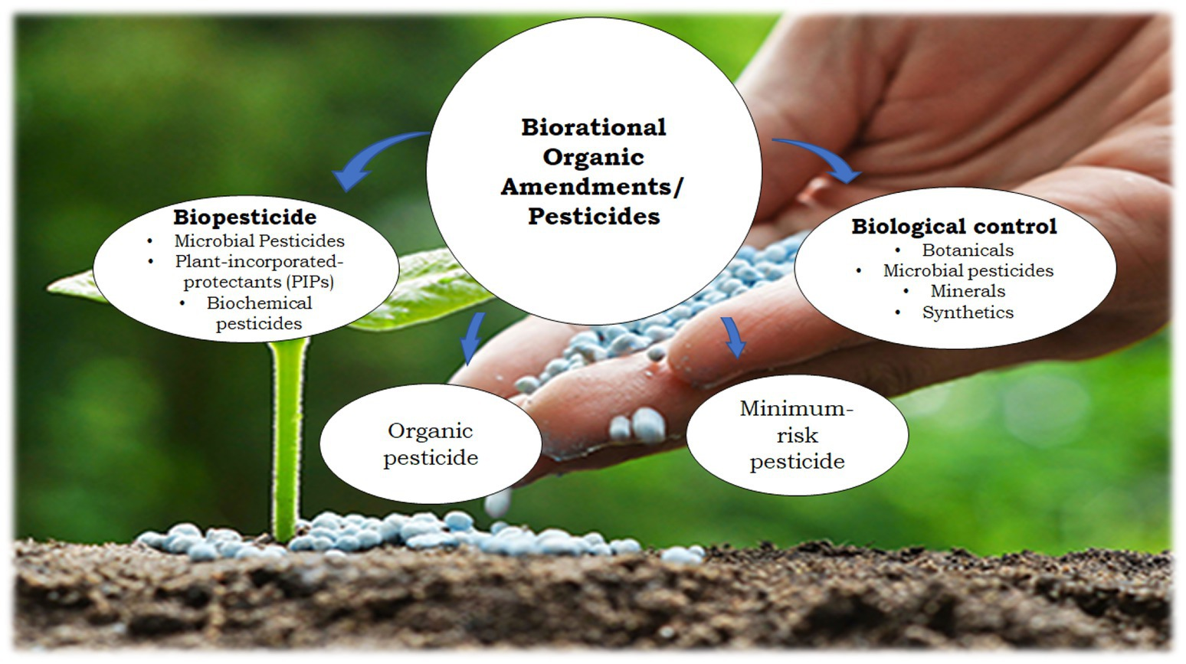

**8.10. Antibiotics**

* Antibiotics = Chemicals made by microorganisms that **kill or slow down** the growth of harmful microbes.
* Effective against **bacteria and some fungi** but **not viruses**.

**8.10.1. Discovery of Penicillin**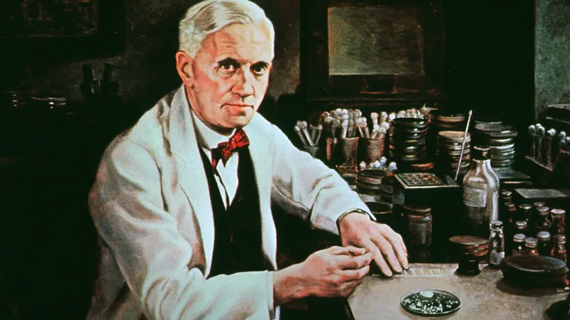

* Discovered accidentally by **Alexander Fleming** in 1928.
* While growing bacteria in dishes, he observed that mold (*Penicillium notatum*) produced a substance that killed bacteria.
* This substance was named **Penicillin** – the **first true antibiotic**
* In the 1940s, Penicillin became widely used and saved millions of lives.
* Today, many different antibiotics are available.

### **8.10.2. Sources of Antibiotics**

1. **Bacteria** – e.g., Streptomycin, Tetracycline, Erythromycin.
2. **Fungi** – e.g., Penicillin, Cephalosporin.
3. **Plants** – some produce antibiotic-like substances (e.g., garlic).
4. **Animals** – some, like frogs, produce protective antibiotic chemicals.

### **8.10.3. Mode of Action (How Antibiotics Work)**

Antibiotics work by interfering with **vital bacterial processes**, leading to death or stopping growth.

* **Cell Wall Inhibition** – e.g., Penicillin blocks bacterial cell wall synthesis.
* **Protein Synthesis Inhibition** – e.g., Tetracycline stops bacterial ribosomes from making proteins.
* **DNA Replication Inhibition** – e.g., Gentamicin prevents DNA copying.
* **Membrane Damage** – e.g., Polymyxins break bacterial cell membrane.
* **Metabolic Inhibition** – e.g., Sulfonamides block enzymes needed for metabolism.

**8.10.4. Classification of Antibiotics**

* **Bactericidal** – Kill bacteria directly.
* **Bacteriostatic** – Stop growth, allowing immune system to remove bacteria.
* **Narrow-Spectrum** – Work on specific bacteria (e.g., Penicillin).
* **Broad-Spectrum** – Act on a wide variety of bacteria (e.g., Tetracycline, Cephalosporin).

**8.10.5. Antibiotic Resistance**

* **Definition:** Ability of bacteria to survive even in presence of antibiotics.
* **Cause:** Overuse or misuse of antibiotics → bacteria develop resistance.
* **Result:**
  + Infections become **harder to treat**.
  + **Longer treatment required**.
  + **Higher healthcare costs**.
  + Some diseases become life-threatening (e.g., drug-resistant TB, drug-resistant typhoid).



